7. Methods

7.5 Pade Approximants

Question 1:

$f_{1}\left(x\right)={\left(1+x\right)}^{\frac{1}{2}}$

$$f_{1}\left(0\right)=1$$

${f^{'}}_{1}\left(0\right)=\frac{1}{2}{\left(1+\left(0\right)\right)}^{-\frac{1}{2}}=\frac{1}{2}$

${f''}_{1}\left(0\right)=-\frac{1}{4}{\left(1+\left(0\right)\right)}^{-\frac{3}{2}}=-\frac{1}{4}$

$$f_{1}^{\left(k\right)}\left(0\right)={\left(-1\right)}^{\left(k\right)}2^{-k}\prod_{n=0}^{k-1}{\left(2n-1\right)} for k≥1$$

Therefore, $$c_{k}=\frac{1}{k!}{{\left(-1\right)}^{k}\left(2^{-1}\right)}^{\left(k\right)}\prod_{n=0}^{k-1}{\left(2n-1\right)} for k≥1$$

and $c_{0}=1$.

1. Radius of convergence: 1; The distance to the nearest singularity/branch point for $f_{1}\left(x\right)$ is 1 at $x=-1$ on a complex plane.

We will require |x| <1 when we use the power series to estimate $f_{1}\left(x\right)$ otherwise the approximation diverges.

$$\sqrt{2}=1.414213562$$

|  |  |  |
| --- | --- | --- |
| $$N$$ | $\sum_{k=0}^{N}{c_{k}}$ | Error |
| 5 | 1.42578125 | -0.011567687 |
| 10 | 1.409931182861328 | 0.0042823795 |
| 20 | 1.412667185988539 | 0.0015463763 |
| 50 | 1.413817654785574 | 0.0003959075 |
| 100 | 1.414073047717716 | 0.0001405146 |
| 150 | 1.414136978762613 | 0.0000765836 |

Table 1: partial sums as N increases

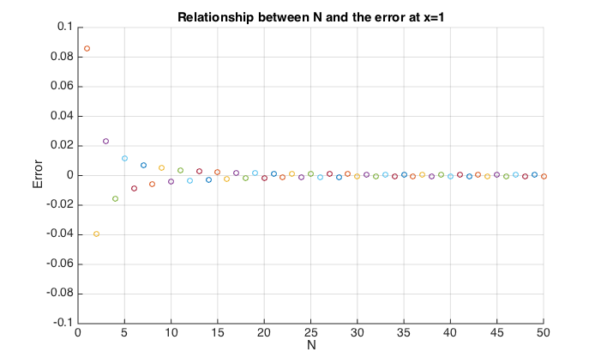

Figure 1: Relationship between N and the error at x=1

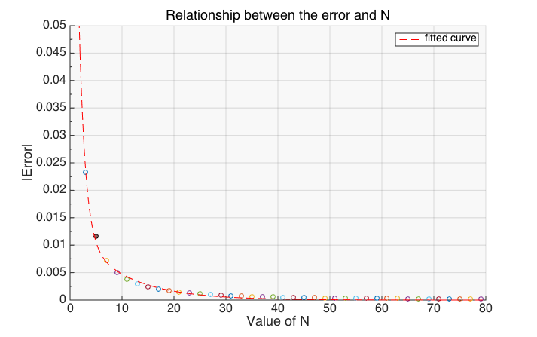 From the graph, the magnitude of the error decreases exponentially as the value of N increases linearly and it also shows a sign changing oscillation on the error as N increases and those results can be explained from the coefficient formula.

Deriving from the formula, we get:

$$c_{k}=\frac{1}{k}\left(-1){(2}^{-1}\right)\left(2\left(k-1\right)-1\right)c_{k-1}=Ac_{k-1} for k≥1$$

1. $\left|A\right|=\left|\frac{2k-3}{2k}\right|<1$; b) $\left|A\right|→1 as k→∞$; c) factor of (-1)

From b) and c), we can deduce that the partial sum should converges as N tends to large because each of the successive terms are (nearly fully) cancelling each other out. Due to the three conditions and $Error=\sum_{i=N+1}^{∞}{c_{i}}$, the error should decreases exponentially (to 0) and shows a sign-changing oscillation as N increases.

|  |  |  |
| --- | --- | --- |
| $$L$$ | $Pade Approximant R_{L,L}$ | Error |
| 3 | 1.414201183431953 | 1.237894114258786e-05 |
| 5 | 1.414213551646055 | 1.072704036708672e-08 |
| 8 | 1.414213562372821 | 2.740030424774886e-13 |
| 10 | 1.414213562373095 | 4.440892098500626e-16 |
| 15 | 1.414213562373095 | -2.22044604925031e-16 |
| 20 | 1.414213562373095 | -2.22044604925031e-16 |
| 25 | 1.414213562373094 | -8.88178419700125e-16 |
| 30 | 1.414213562373095 | -4.44089209850063e-16 |
| 100 | 1.414213562373095 | -2.22044604925031e-16 |

Question 2: (assumed L=M unless indicated otherwise)

Table 2: Pade Approximation's Error as L increases

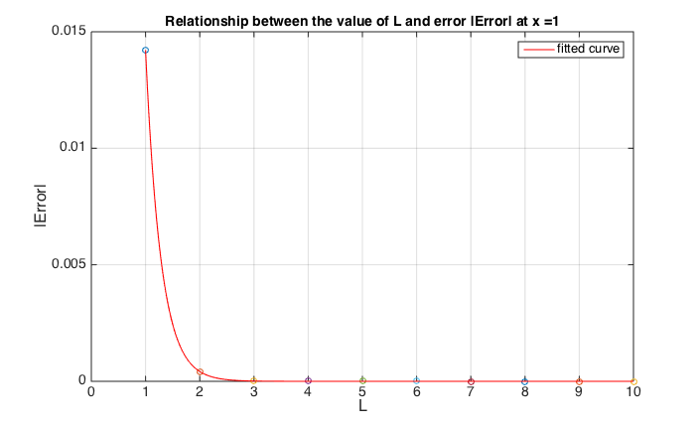

Figure 2: Relationship between L and the magnitude of error at x=1

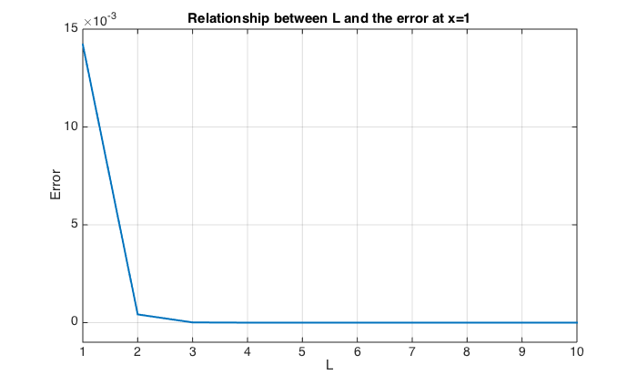

Figure 3: Relationship between L and the error at x=1

From the graphs, we can see the error reduce significantly as L increases. By plotting a curve of best fit, we can see there is an exponential decreases as L increases. The exponential decrease could be explained by the same reason in Q1 as $R_{L,L}\sim Powerseries(2L)$ and $rror=\sum_{i=2L+1}^{∞}{{c'}_{i}}$. Although the error did not improve in exponential manner for L greater than 10, I believe it is due to the inaccurate result suffered from the matrix for solving the system of differential equations getting close to singular. We shall investigate more on why the change in magnitude of the error comparing with the power series. However, I can also deduce that it is a constraint of using Pade approximation comparing with power series approximation. I cannot choose the error to be arbitrarily small as the error stays stable at ${10}^{-16}$ no matter how large L we choose for the approximation. Therefore, the smallest value to which the error can be reduced is around $2*{10}^{-16}$ and this smallest value determines by the size of L we choose.

|  |  |
| --- | --- |
| Iteration | Error |
| 5 | -1.23430499847512e-05 |
|  | -5.29647132990662e-05 |
|  | -9.44918288578296e-05 |
|  | -9.06946369049941e-05 |
|  | -5.06061841238004e-05 |
|  | -1.65426314057550e-05 |
|  | -3.02905850522778e-06 |
|  | -2.77032515608707e-07 |
|  | -9.72729302810274e-09 |
|  | -5.60841668160196e-11 |

|  |  |
| --- | --- |
| Iteration | Error |
| 1 | 7.97188565670195e-06 |
|  | 3.42532343592588e-05 |
|  | 6.11993341672699e-05 |
|  | 5.88358665660897e-05 |
|  | 3.28892688872149e-05 |
|  | 1.07731030737142e-05 |
|  | 1.97715730553159e-06 |
|  | 1.81298176543277e-07 |
|  | 6.38474620117571e-09 |
|  | 3.69400455507437e-11 |

|  |  |
| --- | --- |
| Iteration | Error |
| 10 | 7.03476546956977e-06 |
|  | 3.03261488832999e-05 |
|  | 5.43869966571571e-05 |
|  | 5.25142833502190e-05 |
|  | 2.95050447244694e-05 |
|  | 9.72300833770241e-06 |
|  | 1.79746675428985e-06 |
|  | 1.66307431517344e-07 |
|  | 5.92396986990842e-09 |
|  | 3.47948155534163e-11 |

After running the iterative improvement, it does not improve the error much after 5 iterations for L=M=5. The methods did not show any significance of improvement on the error as the number of iteration increases.

Comparing the tables from Q1 and Q2, we can clearly see that Pade approximation converges to the actual value quicker than the power series approximation by far. From the samples I generated, the error of Pade approximation is at least less than ${10}^{-5}$ while for power series, we will need up to and include the 150 terms for an approximation having a same accuracy. Therefore, regarding to get the most accurate approximation, I will suggest the use of Pade approximation over the power series.

If we aim to estimate for $\sqrt{2}$ to specified accuracy, I will suggest the use of power series because it is easier to identify the exact number of terms which we need to include for an estimation to a specified accuracy and there is a limit on the smallest value of error can be reduced in Pade Approximation as suggested in part 1. With the use of the recurrence formula stated in Q1, we can easily find the smallest N such that $|A^{N}|$ is smaller than the required accuracy. While working in Pade approximation, it requires more work to recognise the number of terms needed for an approximation to required accuracy and we cannot reduce any further error with magnitude smaller than $2*{10}^{-16}$.

In addition, Pade approximation works at order o(M(M+L)) which includes solving M simultaneous equations for Q and L+1 calculations for P while power series requires only N calculations for each approximation. It requires more work for Pade approximation than power series although Pade approximation gives us an incomparably more accurate result than using power series up to the closest $2*{10}^{-16}$.

Question 3:

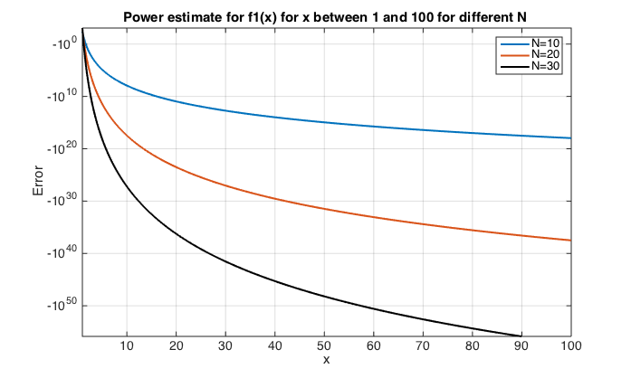

Figure 4: Power Approximation for f_1 for x between 1 and 100 for different N (even)

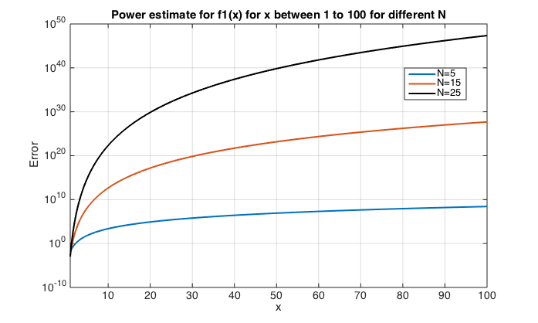

Figure 5: Power Approximation for f_1 for x between 1 to 100 for different N (odd)

Characteristics obtained from the graphs:

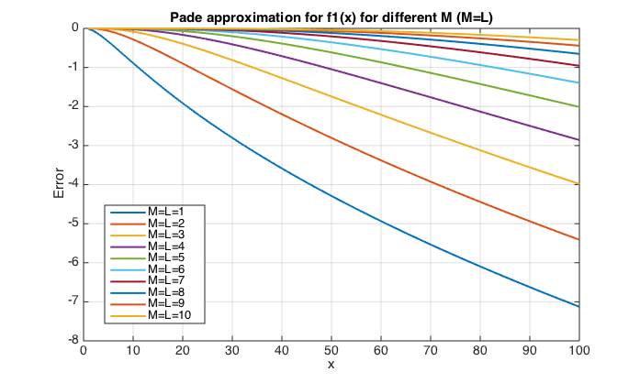

Figure 6: Pade approximation for f_1 with different M as x varies

For power series approximation:   
*1a) the magnitude of the error increases exponentially as x increases linearly  
2a) the magnitude of the error increases exponentially as N increases linearly  
3a) a sign-changing oscillation on the error as N increases*

For Pade approximation:  
*1b) the magnitude of the error increases logarithmically as x increases linearly  
2b) the magnitude of the error decreases at inverse logarithmical manner as L increases linearly*

Comparing two graphs, we can see the magnitude of the error in power series is greater than in Pade approximation overall from x=1 to 100. The difference in error from the two approximations diverges in an exponential manner as x increases with the range of error for Pade approximation and power series approximation varies from 0 to -8 and 0 to ${10}^{47}$ respectively. This shows Pade approximation gives higher accuracy than power series approximation.

Observation 1a) and 1b) can be explained by the fact that the rate of error reduces/ increases is affected by the distance between the evaluated point and the radius of convergence. The further we evaluated from the radius of convergence, the quicker the error increases.

There is a significant difference between the number of terms being considered and the magnitude of error within two approximation. For x greater than 1, the error in the Pade approximation decrease as more terms being considered while the error in power series approximation increases in an exponential manner as N increases. This is because the more terms we accepted in power series (which means the expansion is at higher order of x), the greater divergence we get as x being greater than 1 and the coefficient of the expansion does not tend to 0 as quick. The exponential increases can be explained by $$\sum_{i=0}^{N}{a_{i}{\left(x\right)}^{i}}-\sum_{i=0}^{N}{a_{i}{\left(x+ε\right)}^{i}}=o(x^{N-1})$$

(((((((((Why pade decrease?))))))))

On the other hand, from the graph, we can see the power series approximation with N being odd tends to overestimation while N being even leads to underestimation. This could be because the coefficient of the power series we used to approximate has a factor of ${\left(-1\right)}^{N}$ and given that the series diverges, the leading term of the polynomial dominates the sign of the series which caused oscillate around the actual result as N changes.

In conclusion, pade approximation gives a better approximation than power series although both approximation shows some extends of divergence from the actual result from the graph as x increases which is due to the distance from the evaluated point to the radius of convergence increases.

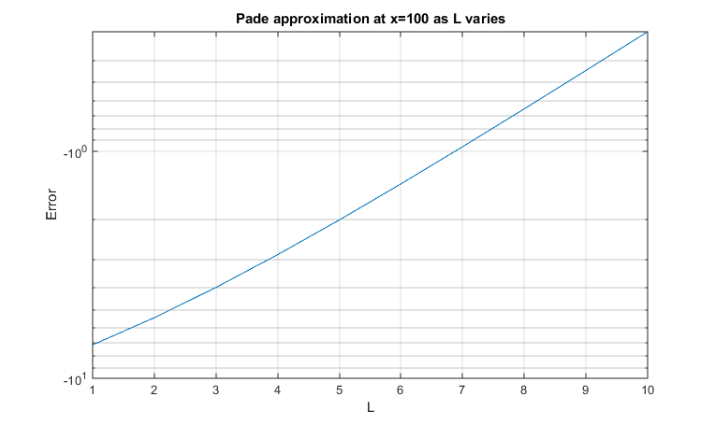

Figure 10: Pade approximation at x=1-0 as L varies (Semi-Log plot)

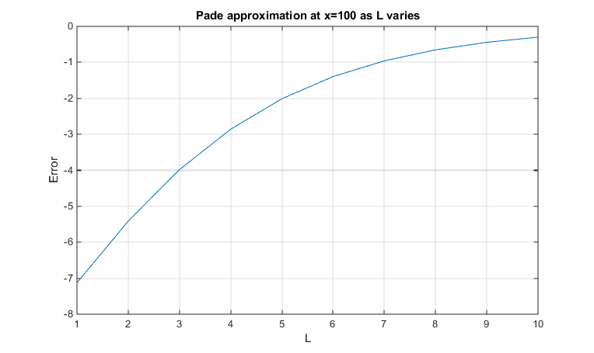

Figure 9: Pade approximation at x=100 as L varies (Linear plot)

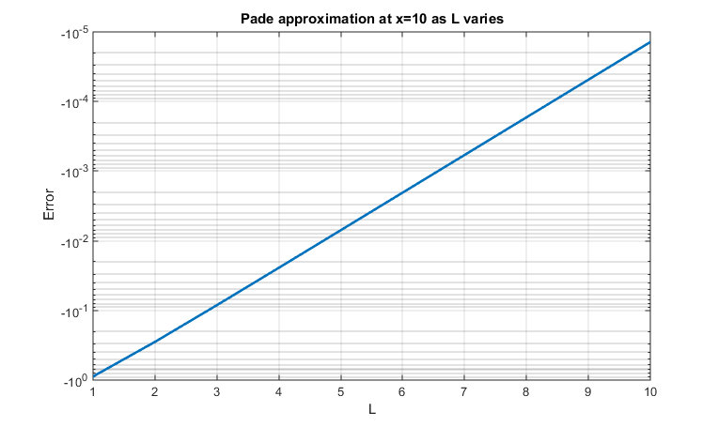

Figure 8: Pade approximation at x=10 as L varies (Semi-Log plot)

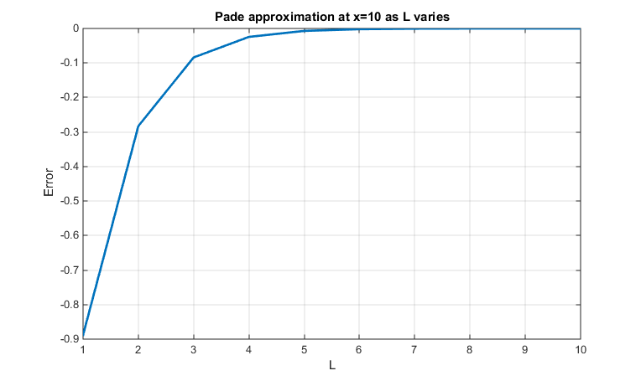

Figure 7: Pade approximation at x=10 as L varies (Linear plot)

Similar to part 1, from the two we can see the magnitude of the error decreases at inverse logarithmical manner as L increases and the relationship between the size of error and the value of L is kept in an inverse log regardless where we are evaluating. The reason behind the rate of the error decrease being logarithmic can be explained by++++++++++++

The implication for using Pade approximant to estimate $f_{1}(x)$ for large x is the error increases at an inverse logarithmic manner as x increases however, we can compensate with the increase in error by increasing the value for L which also has an inverse logarithmic effect on the size of error no matter where we are evaluating.

Investigate how pade error varies as L increases;

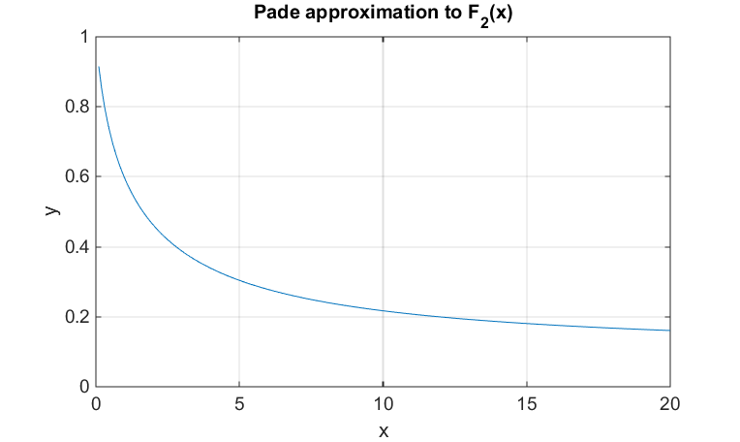Question 4:

Figure 11: Pade approximation to f_2(x) between x=0.1 to 20

|  |  |  |  |  |  |
| --- | --- | --- | --- | --- | --- |
| X | Actual | N=3 | N=4 | N=5 | N=6 |
| 0.1 | 0.91563334 | 0.914000 | 0.916400 | 0.91520 | 0.915920 |
| 0.2 | 0.85211088 | 0.832000 | 0.870400 | 0.83200 | 0.878080 |
| 0.3 | 0.80118628 | 0.718000 | 0.912400 | 0.62080 | 1.145680 |

From the table, we can easily identify that the relative error in the truncated power series is, again, incomparably large (varying from ${10}^{9}-{10}^{32}$) comparing with the relative error occurs in Pade approximation for all value of x across 0.1 to 20. Although the error in power series approximation starts off relatively low when x is small, it experiences an exponential increase as x increases and diverges to over ${10}^{31}$. This is because the partial sum of the power series diverges for any non-zero x. The series has a better approximation if we include less term in the series with small x because each extra term we consider, we are adding/subtracting a value of $k!x^{k}=kx\left(k-1\right)!x^{k-1}=\left(kx-1\right)\left(k-1\right)!x^{k-1}+\left(k-1\right)!x^{k-1}$ to the partial sum, which substantially means cancelling out the last term of the partial sum and add back $|\left(kx-1\right)\left(k-1\right)!x^{k-1}|$ to the magnitude of the partial sum. As the partial sum now has the magnitude of $|\left(kx-1\right)\left(k-1\right)!x^{k-1}|$, the partial sums should remain stable and relatively accurate up to the smallest value of $k$ such that $kx>1$. Example as followed:

From the integral expression of $f_{2}(x)$, we can deduce that $f_{2}(x)$ is a decreasing function in x. However, according to the power series, it shows a divergent behaviour as x increases. Therefore, as a basis for calculating $f_{2}(x)$, truncated power series do not give much useful information at all which can also be reflected on the magnitude of error in the table.

Regarding the use of Pade approximation to $f_{2}(x)$, it shows a promising accuracy to the actual value as x increases. A clear trend of $f_{2}(x)$ being a monotonic decreasing function in x is clearly reflected from the graph which matches with our observation of the behaviour of $f_{2}(x)$. As x increases, although the relative error increases, it still under a reasonable range at x=20 with around 24%. I believe the relative error will increase as x increases but a clear sign of convergence to 0 is spotted from the approximation.

Even though the order of Pade approximation is higher than the power series approximation, as a basis for calculating $f_{2}(x)$, we should use the Pade approximation over the power series approximation as we can get barely any information from the latter method.

Question 5:

From the graphs for $f_{1}(x)$, we can see the position of the poles and zeros have kept the same pattern of distribution along the negative real axis starting from -1 and reaching out to negative infinity as L increases. The poles and zeros only exist on the left of -1 on the negative real axis for L smaller than 10. As L reaches 10, the poles and zeros start distributing not only on the negative real axis but also over the complex plane. However, we can clearly see that the poles and zeros are always overlapping each other on the complex plane at positions except the negative real axis. This could make those poles cancelled out by the zeros which enable us to ignore those poles when we considering the radius of convergence of the approximation of $f_{1}(x)$.

From the graphs for $f_{3}(x)$, we can spot the four graphs is fundamentally the same as the graphs for $f_{1}(x)$ with the position of the poles and zeros swapped. This is because $f_{3}=\frac{1}{f_{1}}$, therefore the Pade approximation for $f_{3}$ is the reciprocal of the approximation for $f_{1}$. Similar trend has shown here as in $f_{1}(x)$, the poles and zeros hold in the same pattern on the negative axis starting from the left of -1 and tending to the negative real infinity as L increases. As L becomes large, poles and zeros start distributing around the whole complex plane, however they are always overlapping each other at those position which cancelled out each other from the Pade rational function approximation to $f_{3}$.

For $f_{4}(x)$, we no longer only spot the poles and zeros on the negative real axis anymore. All the poles are distributed evenly in an arc shape on the positive real side on the complex plane while all the zeros distributed on the negative real side on the complex plane similarly in an arc shape. As L increases, the poles and zeros have kept in an arc shape with increasing radius on each side. However, as L becomes large, the arc shape flattens a bit and a semi-oval shape formed for poles and zeros. In addition, as $f_{4}(x)$ is complete, all the poles on the complex plane are anomalous and as L gets to around 50, the positions of the poles and zeros no longer follow the elliptic pattern and, as we can see, two odd poles appear on the real axis and tend to infinity on both sides.

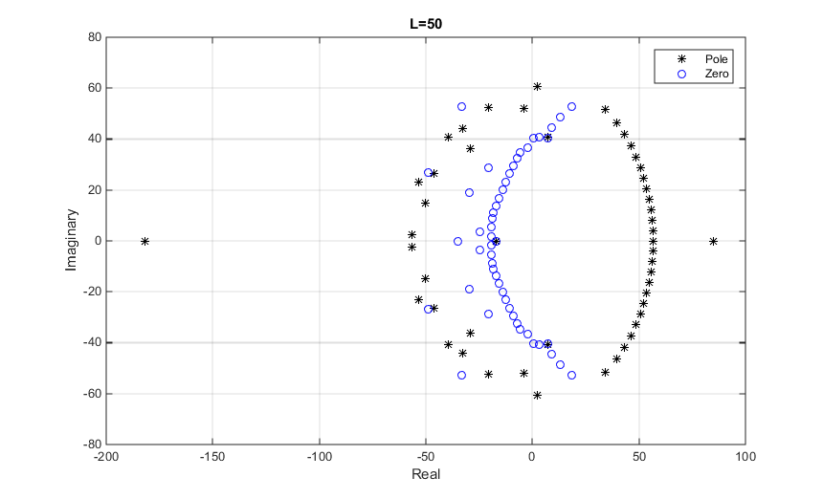

For $f_{5}(x)$, we can see a similar arc shape distribution as $f_{4}(x)$ on the complex plane with a pole at -1 on the negative real axis. However, as L increases, the magnitude of the radius of the arc oscillate between 5 and 10 for both the poles and zeros but not tending to infinity as in $f_{4}(x)$. As L becomes large, the distribution of the poles start invading the left hand side on the complex plane and similarly the zeros getting onto the right hand side as well although the arc shapes with oscillating radius are still kept for both the poles and zeros at large L. Except the pole at -1, all other poles are anomalous

For $f_{6}(x)$, we can see the majority of poles and zeros distributed on the imaginary axis except 2 points. As L increases, the positions of the poles and zeros on the imaginary axis do not change much and stay around $i and-i$ on the complex plane. However, for the 2 outstanding points, both of them are on the real axis and with one of them being poles and zeros alternatively as L increases stepwise at the position of -2. For the other outstanding point which is always a pole, it alters its sign with tendency to infinity as L increases.

|  |  |  |  |  |  |  |  |
| --- | --- | --- | --- | --- | --- | --- | --- |
| **X** | **Actual Value** | **Pade Approximation (L=M=10)** | | | **Power Series Approximation (N=15)** | | |
| $$f_{2}\left(x\right)$$ | $$f_{2}\left(x\right)$$ | **Error** | **(%)** | $$f_{2}\left(x\right)$$ | **Error** | **(%)** |
| 0.1 | 0.91563334 | 0.915633 | -6.06019E-08 | -6.61858E-06 | 0.91484044 | -0.00079 | -0.0866 |
| 0.2 | 0.85211088 | 0.852111 | 1.79275E-09 | 2.1039E-07 | -31.42068165 | -32.2728 | -3787.39 |
| 0.3 | 0.80118628 | 0.801186 | 1.3659E-08 | 1.70484E-06 | -15385.95186 | -15386.8 | -1920496 |
| 0.4 | 0.75881459 | 0.758815 | 1.32262E-07 | 1.74301E-05 | -1205207.548 | -1205208 | -1.6E+08 |
| 0.5 | 0.72265723 | 0.722658 | 6.24763E-07 | 8.64536E-05 | -35245832.94 | -3.5E+07 | -4.9E+09 |
| 0.6 | 0.69122594 | 0.691228 | 1.98126E-06 | 0.000286629 | -553748521.2 | -5.5E+08 | -8E+10 |
| 0.7 | 0.66351027 | 0.663515 | 4.91558E-06 | 0.000740844 | -5.67E+09 | -5.7E+09 | -8.5E+11 |
| 0.8 | 0.6387911 | 0.638801 | 1.02389E-05 | 0.001602852 | -4.25E+10 | -4.2E+10 | -6.7E+12 |
| 0.9 | 0.61653779 | 0.616557 | 1.88182E-05 | 0.003052243 | -2.51E+11 | -2.5E+11 | -4.1E+13 |
| 1 | 0.59634736 | 0.596379 | 3.15238E-05 | 0.005286148 | -1.23E+12 | -1.2E+12 | -2.1E+14 |
| 2 | 0.46145532 | 0.461960 | 0.000505175 | 0.109474403 | -4.15E+16 | -4.1E+16 | -9E+18 |
| 3 | 0.38560201 | 0.387274 | 0.001671949 | 0.433594569 | -1.84E+19 | -1.8E+19 | -4.8E+21 |
| 4 | 0.33522136 | 0.338565 | 0.003343908 | 0.997522332 | -1.38E+21 | -1.4E+21 | -4.1E+23 |
| 5 | 0.29866975 | 0.303969 | 0.005299605 | 1.774402977 | -3.94E+22 | -3.9E+22 | -1.3E+25 |
| 6 | 0.27063301 | 0.278017 | 0.007384201 | 2.728492272 | -6.08E+23 | -6.1E+23 | -2.2E+26 |
| 7 | 0.24828135 | 0.257783 | 0.009501752 | 3.827009971 | -6.15E+24 | -6.1E+24 | -2.5E+27 |
| 8 | 0.22994778 | 0.241543 | 0.01159563 | 5.042723063 | -4.56E+25 | -4.6E+25 | -2E+28 |
| 9 | 0.2145771 | 0.228211 | 0.013633636 | 6.353723642 | -2.67E+26 | -2.7E+26 | -1.2E+29 |
| 10 | 0.20146425 | 0.217063 | 0.015598475 | 7.7425525 | -1.30E+27 | -1.3E+27 | -6.4E+29 |
| 11 | 0.19011779 | 0.207600 | 0.017481876 | 9.195286529 | -5.43E+27 | -5.4E+27 | -2.9E+30 |
| 12 | 0.18018332 | 0.199464 | 0.019281009 | 10.70077346 | -2.00E+28 | -2E+28 | -1.1E+31 |
| 13 | 0.171398 | 0.192394 | 0.020996304 | 12.25002849 | -6.66E+28 | -6.7E+28 | -3.9E+31 |
| 14 | 0.16356229 | 0.186192 | 0.022630063 | 13.83574571 | -2.02E+29 | -2E+29 | -1.2E+32 |
| 15 | 0.15652164 | 0.180707 | 0.02418564 | 15.45194661 | -5.70E+29 | -5.7E+29 | -3.6E+32 |
| 16 | 0.15015426 | 0.175821 | 0.025666934 | 17.09371014 | -1.50E+30 | -1.5E+30 | -1E+33 |
| 17 | 0.14436271 | 0.171441 | 0.027078074 | 18.75697256 | -3.73E+30 | -3.7E+30 | -2.6E+33 |
| 18 | 0.13906806 | 0.167491 | 0.028423156 | 20.43830595 | -8.79E+30 | -8.8E+30 | -6.3E+33 |
| 19 | 0.13420555 | 0.163912 | 0.029706212 | 22.1348607 | -1.98E+31 | -2E+31 | -1.5E+34 |
| 20 | 0.12972152 | 0.160653 | 0.030931099 | 23.84423137 | -4.27E+31 | -4.3E+31 | -3.3E+34 |

Relative Error (%)=(Errror/Actual Value)*100

$$f_{1}\left(x\right)=\sqrt{1+x}$$

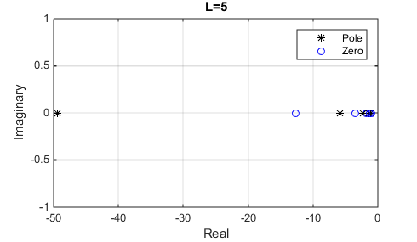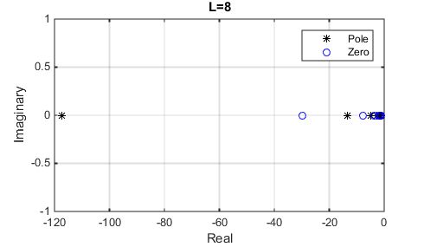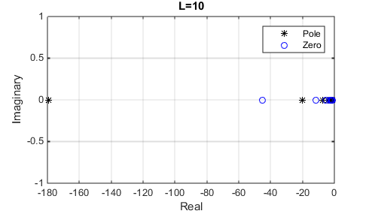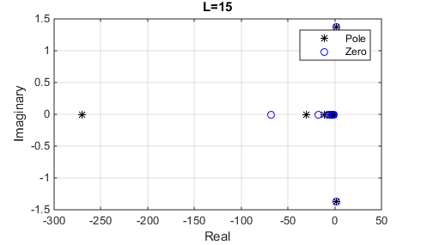

$$f_{3}\left(x\right)=\frac{1}{\sqrt{1+x}}$$

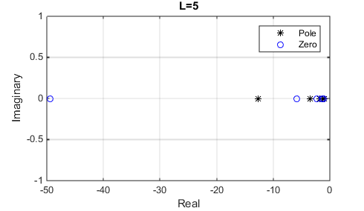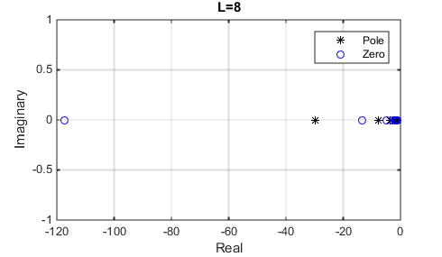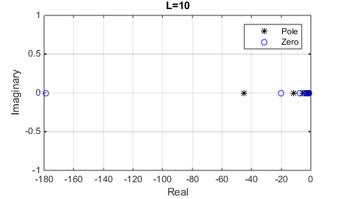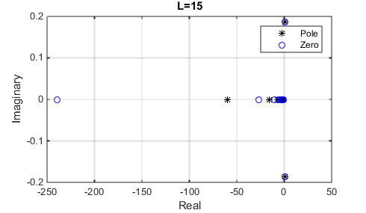

$$f_{4}\left(x\right)=e^{x}$$

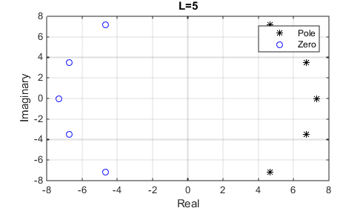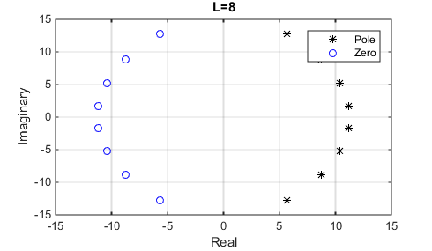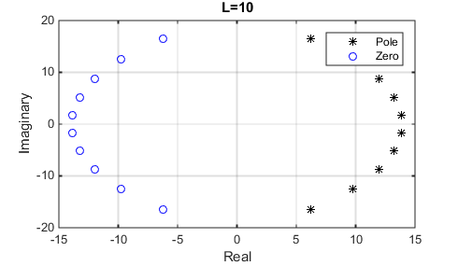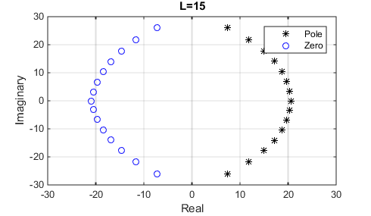

$$f_{5}\left(x\right)=\frac{e^{x}}{1+x}$$

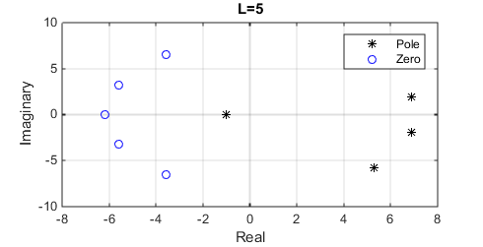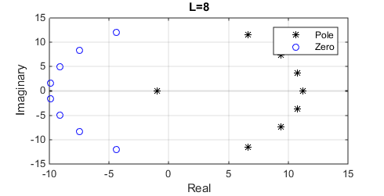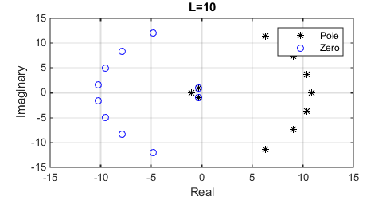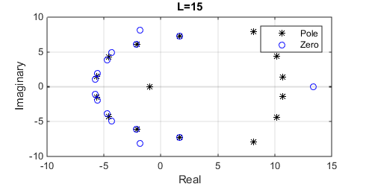

$$f_{6}\left(x\right)={\left(1+x+x^{2}\right)}^{\frac{1}{2}}$$

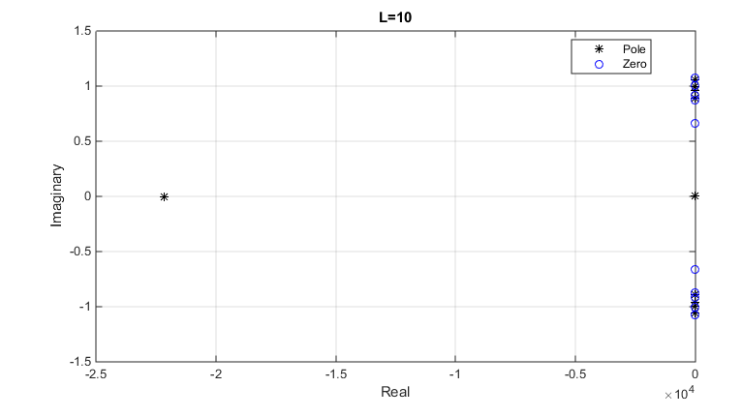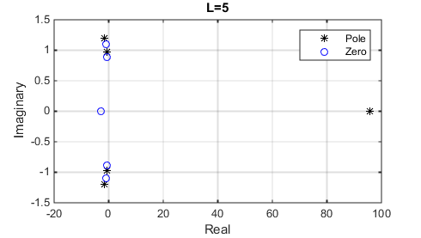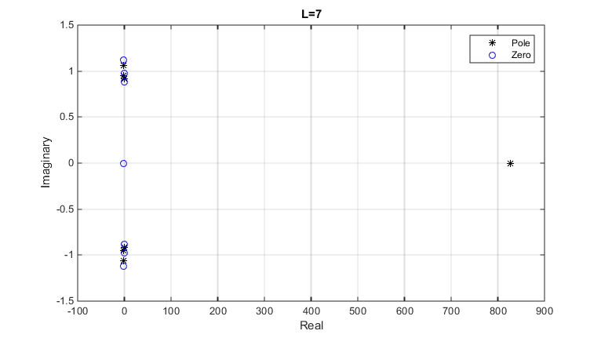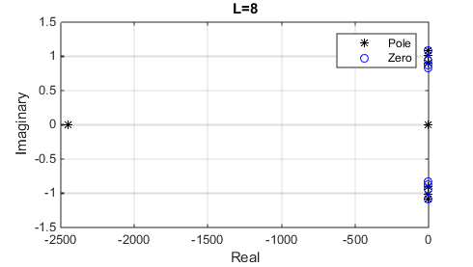

2. $f_{1}\left(x\right)=\sqrt{1+x}$

Analytically, we can deduce that there is a branch point at x=-1 and x=∞ in $f_{1}\left(x\right)$ for which we may introduce a branch cut on the real axis from x=-1 to +infinity. From the graph, we can see majority of the poles and zeros are lying on the other side of the suggested branch cut for any value of L. As L increases, the position of poles and zeros tends to infinity with increasing spacing between the poles and zeros. On the other hand, at L=15, we can see two outstanding poles and zeros lying on the imaginary axis which are classified as anomalous poles and zeros. For L larger than 15, we can see there are more anomalous poles and zeros appearing outside the branch cut on the imaginary axis. However, the poles and zeros are always appear to be overlapping each other which essentially making the poles become removable singularities/ poles at order 0. This eased the effect of those poles and zeros on the approximant’s radius of convergence and also the behaviour of the approximant to the original function.

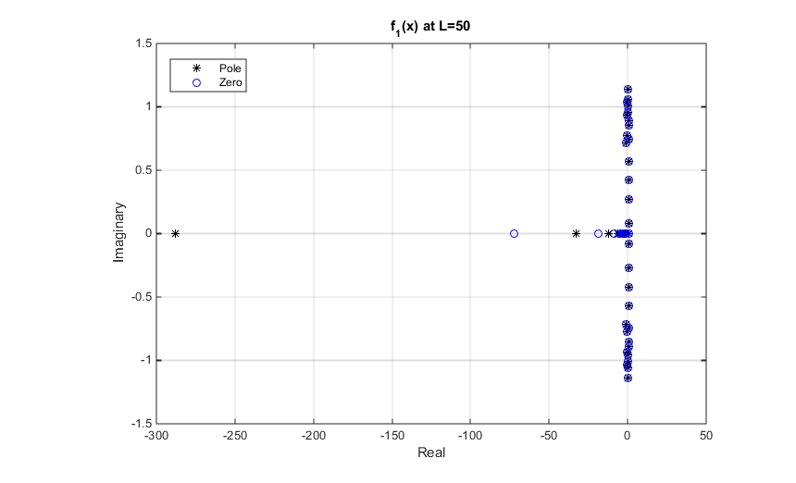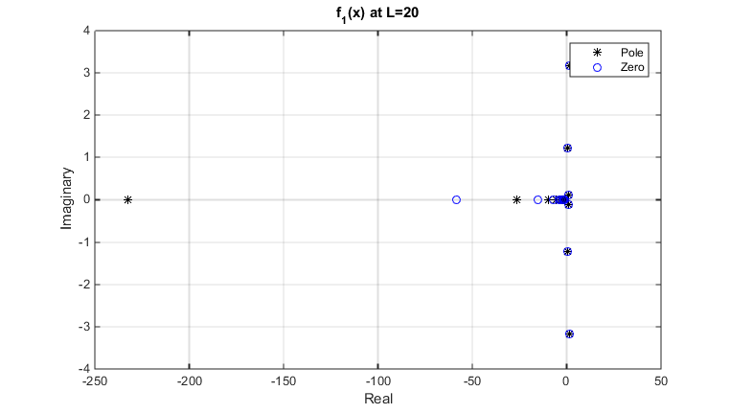

The increasing spacing between poles suggests that the approximant we are taking for the original function has a larger radius of convergence as L increases because we can then translate the point on the real axis we evaluate our function to the middle of the two most apart poles, given that we cannot evaluate at any point on the branch cut. It will allow us to take a better/converge approximation for points which will cause divergence if we have used the power series estimation.

In $f_{3}\left(x\right)$, we can see there is a pole at x=-1 and two branch points at x=∞ and x=-1 which is similar to our $f_{1}\left(x\right)$. We can construct the same branch cut here and from the graph, we can see $f_{3}\left(x\right)$ behaves exactly the same except the positions of poles and zeros swapped. We could expect $f_{3}\left(x\right)$ shares the same property of the convergence as $f_{1}\left(x\right)$, however, the radius of convergence will increase slower in $f_{3}\left(x\right)$ than in $f_{1}\left(x\right)$ because the largest distance of the zeros increases slower than the poles’ in $f_{1}\left(x\right)$.